Stoney Point – 2026 - April

Agenda
Attendees
John Parker Fairview
Marc-Andre Lussier Fairview
Chris Hosein 2nd Westmount
Melanie Laberge TMR
Margaret Fraser Trinity
Griffin Leahey Westmount Park
Mike Kehle Valois
Amanda Thorburn Rosemere
Patrick Purtell Rosemere
Nick Fatica Summerlea
Dan Wylie Strathmore
Thomas Scoffield Jumpscouts
Gerorge Smith Medics
Susan Smith Kitchen
Absent Webmaster

- Roles
Lifeguard – Minh 2nd Westmount
Roles

- Financial update
Special costs for camp – Lifeguard to confirm if staying or not.
Tshirts - $11.95 each
Camp crests ordered - $691

- Website – keep for 2026 / change for 2027?
Margaret provided samples below for all groups to test and provide feedback. Please send comments to John before next meeting.
Example youth form:
https://docs.google.com/forms/d/e/1FAIpQLSf2KleTXPDcE2nH-WP80e3qNycS-nvfL0yQ0tk7WwTDhBtY4g/viewform?usp=publish-editor

Example non-cub form : https://docs.google.com/forms/d/e/1FAIpQLSfMhu8pssQEjuw1EaslilDIYTyu5N5YmVZl-dW9oVd3o0Dfcw/viewform?usp=publish-editor

Kitchen(Sue), accommodations(George), badge(Virginia) to review summaries and provide feedback.
Trinity, Rosemere, 2nd Westmount and TMR to send electronic versions to John to distribute.

- Group numbers
Update based on registrations
John to ask Bradley and Sean for camp forms
If anyone wants to sleep in a tent they need to advise ASAP.
Numbers

- Camp Theme - Midieval
Bad guy / good guy story - Rosemere volunteered
Scavenger hunt – Margaret advised it would be like last year but based on the camp theme (Medieval)
Send in the entertainment form to Christine (form on the website) to Raksha.summerlea@outlook.com

- Badges offered
Badges

- Game ideas
Groups will be 12 – 13 youth per game station
Games

- Any Other Business
- Confirmed Daphnie has the soup (9 packages) and Kyle Farnand will bring to camp
- Rosemere, 2nd Westmount, Strathmore co-ed cabins
- Griffen to bring extra empty ice cream buckets to camp
- Valois to bring up big cooler for water / bug juice
- Ask camp to demo the grill cleaning when Patrick Gabbas arrives on Friday
- Ask to have the life jackets out of garbage bags
- Ask camp about cutlery and cleaning of the grill with Patrick Gabbas on Friday evening

Saturday afternoon free time
Lifeguard at beach – swimming
Badge trade station to ensure fair trades
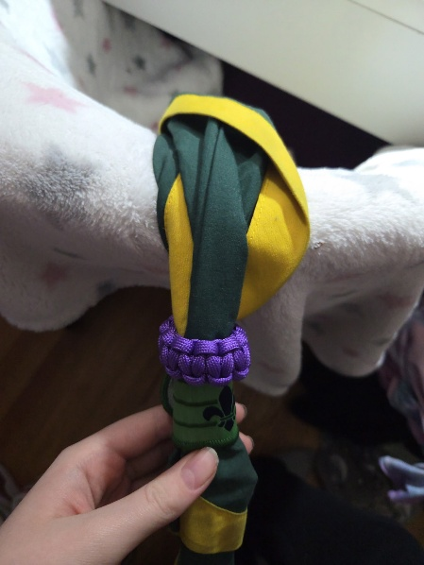
Woggle activity to be run by Chole but youth need to bring up their own power cord, 4 ft per person (see example below)

AOB

- Next planning meeting
May 13 @ 7:30 pm – (Last discussions before camp) – Zoom
June 5 -7 Camp at Kinkora

- Roles
Camp chief (liaison for groups) – John Parker
Assistant Camp Chief – Virginia Elliott
Badge chief – Virginia Elliott
Finance chief – Dan Wylie
Games chief – Nick Fatica
Jump Scouts – Marc Comeau, Thomas Scoffield, Patrick Purtell, Lien Khan Ho
Kitchen chief – Jocelyn Gagnon / Sue Smith / Shannon O’Conor / Lisa O'Brian / Sophie Sodermeyer / Patrick Gabbas
First Aid – Sean Lerman / George Smith / Leonie Gagnon / Bradley Cohen
Lifeguards – Minh 2nd Westmount as backup possibly
Accommodations – George Smith (Plan accommodations to have leaders close to kids – difficult job but best is trying to be done)
Website – Terry Dawson

- Reminders for leaders
  - All groups should participate in the meeting to provide input into the planning
  - All leaders and support staff must have a current PRC and have completed the online course at the time of the camp
  - Send campfire choices (form on the website) to Raksha.summerlea@outlook.com
  - Groups to suggest the accommodation split up for their group if they want/need to.
  - George to bring
    - Trophy (Howler award) for the quietest and cleanest table for each meal
    - Walkie Talkies
    - Water cooler
    - Blank medical forms in case not provided in advance
    - Crests (Old camp ones)
  - Virginia to do / Bring
    - Scouts Own on Saturday/Sunday morning
    - 2 Copies of the med list / allergies
    - 2 Copies of the badge assignments
  - Dan to bring
    - Canadian flag and flag stand
    - Bag with crest design on it
    - 1st / 2nd / 3rd place ribbons
    - Pennants
    - Tshirts
    - Trailer
    - Jumpscout crests
  - John to bring
    - Crests (current camp ones)
    - Picture frame
    - Glue gun
    - Food for camp
    - Copies of schedule
    - Soccer ball
  - Medical
    - Medication to be brought to the medics Friday night (except epi pens & asthma meds) – Ensure medical form has been provided (confidential).
    - Groups manage their own youth’s Medicare cards
    - Leaders to collect the meds and forms for their group and bring to medics
  - KIT LIST
    - Leaders to bring walkie talkies if they have
    - Remind cubs to bring bug nets and bring extra in case they forget (dollar store)
    - Cubs to bring bug repellant – NOT aerosol
    - Cubs should wear light color clothing as it is less attractive for bugs
    - Cubs in Jump scout to bring super soakers (nothing expensive) and dark t-shirt for water games
    - Cubs in Trailcraft to bring older shoes / boots as trails can be muddy
    - Cubs in Emergency 1-2 need to bring a container for medical supplies that will be provided at camp. See sample picture below. If not bring a large Freezer bag.
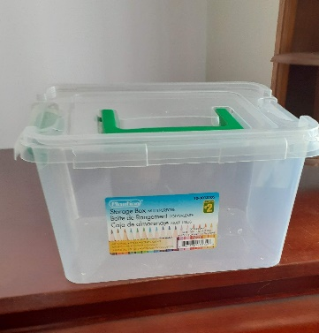
  - At Camp
    - Leaders to collect water guns on Friday night and keep, to give to Thomas Scoffield for Saturday
    - Epi pen quick training on Friday evening
    - Friday night to do introductions for the leaders meeting.
    - Mention Friday night that the camp is for the youth and they are supposed served food first

- Camp checklist
  - Hike trail (lake at top of mountain) - It starts behind Kinkora House (which is across the bridge past the Chapel).
  - Ensure the following
    - Throw bag at the beach
    - Walkie Talkies (Needed for Hike)
    - Canoes / Kayaks

- Accounting (Bank statement / Finance Chief)
  - One cheque per group
  - Cheque to be made out to “Dorval Stoney Point Cub Camp”
  - Please use pack entry summary form from the Strathmore web site. All registration forms will be made available on this site Stony Point Camp web site - click here
  - Groups need to respect the deadline for forms and money payment

- Costs – Dan
  - Cover camp registration costs from camp reserve for staff (kitchen / medics / lifeguards)
  - No food due to allergies – price reduced by food cost - $20
  - Camp Crest –$691
  - Tshirt – $11.95 each
  - Cost per person (incl leaders & support staff)
    - Food costs planned for $20 per/person (TBD based upon food costs)
    - 1 adult to bring own food (Rosemere)
  - Camp price - $110 (youth, leader, kim)
  - Other costs for beads / games / badge work please advise – Submit invoices to Dan

- Kitchen – Jocelyn
  - MAPAQ (Joeclyn has certification)
  - Run our own kitchen – staff depending on numbers at camp but normally 5-6
  - Put tape on tables Friday night and leaders to write numbers to help kitchen be able to setup
  - Sue may need help in bringing food up to camp.
    - George will have access to a trailer for dry goods. Dan will bring trailer with his truck.
    - John has van and can bring up food like last year
    - Virgina also offered to bring up some food
  - Food notes
    - Jumpscout to eat outside on Saturday lunch
    - Add water to tables for meals.
  - Allergies – important to note on the forms Need to ensure list provided to kitchen chief

- Camp Theme
  - Friday night activity
    - Design a crest and or flag / banner / crown/ Sue provided old table clothes to use for crests
    - youth to decorate their cabin
    - Groups can do before camp
    - Activity can be done in kitchen or cabin
  - Bad / Good guy story theme for the weekend – Rosmere
    - Friday night activity
      - Decorate the cabin with crest / banner etc.
    - Saturday Entertainment – Skits in line with the theme
    - Sunday - Wide activity
      - Scavenger hunt – Margaret (Trinity)
      - Tug of war rope Summerlea / Soccer / basketball – split with scavenger hunt for time
  - Start & end times of camp – See schedule on web site
  - Scavenger hunt – Trinity

- Packs & Numbers
 | Beavers |  | Cubs |  |  |  | Kims |  | Leaders |  | Support
Group | Male | Female | Male  Reg | Male  Jump | Female  Reg | Female  Jump | Male | Female | Male | Female | Male | Female
Fairview |  |  | 3 | 3 |  |  |  |  | 1 | 1 | 3
Strathmore |  |  | 10 | 3 | 2 |  |  |  | 4 | 1 | 1 | 3
Valois | 3 |  | 8 | 4 |  |  |  |  | 4 | 1 (parent)
Summerlea | 1 |  | 4 |  |  |  | 1 |  | 4 | 3
2nd Westmount |  |  | 8 | 5 | 5 | 4 |  |  | 2 | 2 |  | 1
Westmount Park |  |  | 5 | 1 | 1 | 1 |  | 1 | 1 | 1
Trinity | 4 | 2 | 8 | 4 | 2 | 1 |  | 1 shadow | 4 | 1
Rosemere |  | 1 | 3 | 2 | 2 |  |  | 1 + 1 shadow | 2 | 1 + 1 parent | 2 | 1
TMR | 1 | 1 | 5 |  | 6 | 1 |  |  | 2 | 3
Total | 19 | 4 | 52 | 19 | 18 | 6 | 6 | 4 | 24 | 15 | 6 | 5
Numbers in red excluded from totals.

- Badge Chief (Badges to be given) – Keep the same choices as last year
  - Medication & allergy list for leaders (running badge), medics and kitchen
  - People running the badge work to provide a list of items covered BEFORE camp
  - Trail skills level 1-2 / 3
    - Level 1-2 - Griffin (Valois)
    - Level 3 – Chris (2nd Westmount)
  - Camping skills level 1-2 / 3
    - Level 1-2 – Nick (Summerlea)
    - Level 3 – Brad (Summerlea)
  - Emergency Level 1-2 & 3-4
    - Level 1-2 - Leonie (Rosemere)
    - Level 3-4 – George & Gary (Summerlea)
  - Paddling skills Level 1 / 2
    - Jumpscouts have watercraft for 1st hour and then paddling can use them afterwards
    - Level 1 Margaret (Trinity)
    - Level 2 Amanda Brown, Gijs (pronounced Hey-s) Langelaan (TMR)

- Games Chief – Nick Fatica (Dan & John Backup)
  - All the locations are close so activities run faster
  - Each game will run for 15 min with a 3 min move between each station.
  - Use the posts for the games & print designs based upon game names
  - Provide snack to leader taking group to the different games
  - Need numbers & arrows on games to help with rotation

  - Pillory Punishment (Sponge Toss) Dan Wylie (Strathmore)
  - Archery (Rosemere)
  - Juggling Jesters (2nd Westmount)
  - Jousting (Valois)
  - Serving the Court Ale & Wine (Summerlea)
  - Storming the Castle (Fairview)
  - Knight’s Training (Westmount Park)
  - Catapult Challenge (TMR)

